SAFEGUARDING CHILDREN
(CHILD PROTECTION)

Everyone has the right to be safe, no matter who they are or what their circumstance.

Safeguarding is about protecting children, young people and vulnerable adults from abuse or neglect.

We are all responsible for the safety of children, young people and vulnerable adults and must ensure that we are doing all we can to protect the most vulnerable members of our society.

The surgery has safeguarding policies to ensure both children and vulnerable adults are safe and our clinicians are trained to identify when people may be at risk of abuse.

This leaflet has been designed to highlight to people what abuse is, how it can be identified and report it to ensure people get the help they need to stay safe and independent.

SAFEGUARDING CHILDREN
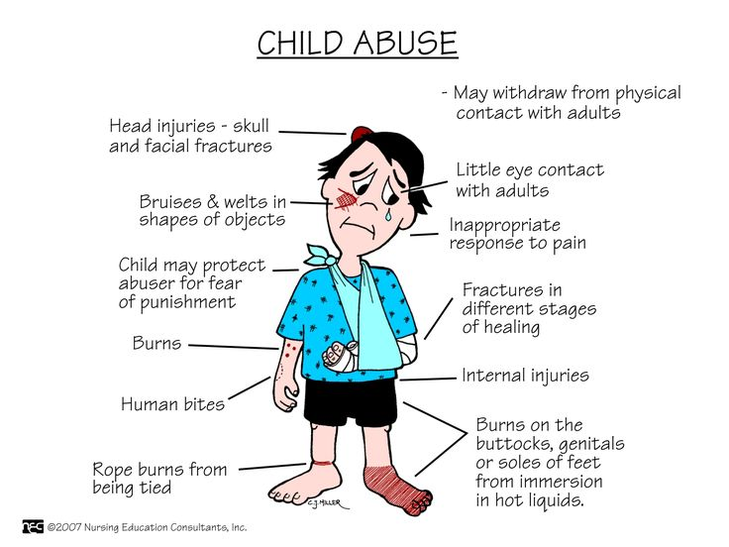

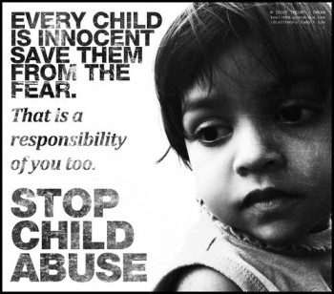

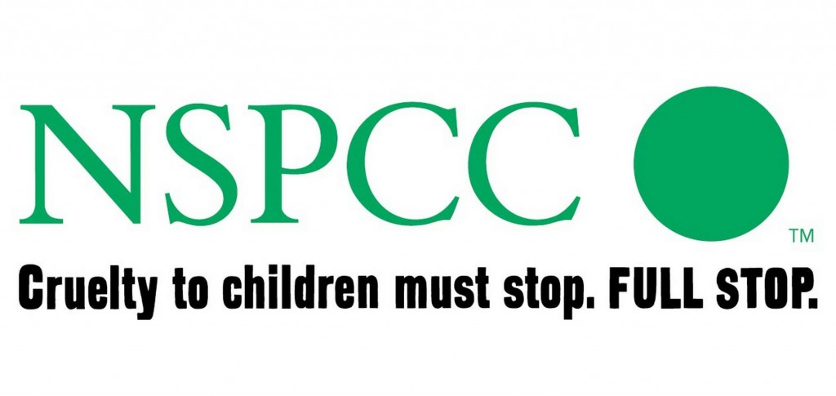

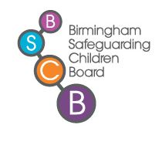

Safeguarding Children

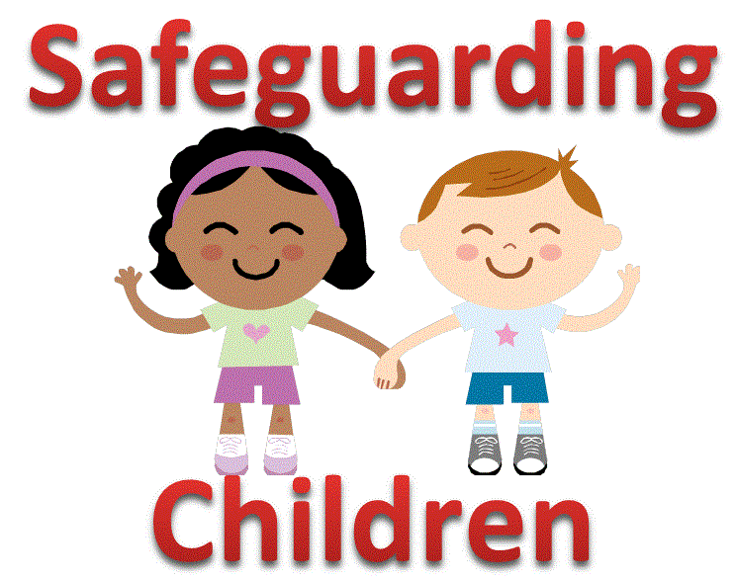

Dr Kulshrestha Summerfield Family Practice
134 Heath Street, Winson Green, Birmingham, B18 7AL
Tel: 0121 411 0362
www.summerfieldfamilypractice.com

PLEASE TAKE A COPY
[Revised February 2021]

Who is responsible for looking after a child’s welfare?
The simple answer is EVERYONE. It is all our responsibility to protect children. All children have a right to grow up in a caring and safe environment. All adults have a responsibility to protect children, including:

- Parents
- Family Members
- Friends
- Neighbours
- Members of the Public
- Professionals

WHAT IS CHILD ABUSE?
There are different types of abuse:

- Physical Injury – being hit, kicked or punched
- Physical Neglect – Not being properly fed or clothed and poor hygiene
- Sexual Abuse – Inappropriate sexual behaviour, language, indecent assault or sexual activity
- Emotional Abuse – Constantly criticised, ignored, humiliated and exposed to family violence.

HOW CAN YOU TELL IF A CHILD IS BEING ABUSED OR NEGLECTED?

Children rarely tell if they are being abused. However there may be signs that concern you, that may be an indication of a child being abused or neglected. The child may:

- Have unexplained bruising or bruising in an unusual place
- Appear afraid, quiet or withdrawn
- Appear afraid to go home
- Appear hungry, tired or unkempt
- Be left unattended or unsupervised
- Have too much responsibility for their age
- Be acting in a sexually inappropriate way
- Be misusing drugs or alcohol

The adult may be:

- Acting in a violent or sexual manner towards a child
- Misusing drink or drugs while caring for a child
- Verbally abusive towards a child

What to do if you are concerned?
If you are concerned about a child’s safety, speak to someone about it. This might be a health visitor, nursery or school staff, a teacher, a police officer, a social worker or a doctor.
Make sure you;
- DO NOT interrogate the child
- Act properly
- Note down your concerns with dates and times
- Give as much information as you can about the child and family

Reporting any concerns:

- IMMEDIATE DANGER 999
- Birmingham Safeguarding Children’s Board [BSCB]: 0121 303 1888
- Email Children’s Advice & Support Service: cass@birminghamchildrentrust.co.uk
- NSPCC Helpline: 0808 8005000
- Email: help@nspcc.org.uk
- SPEAK TO YOUR GP
You should consider contacting the police if you feel there is an immediate danger to the child.

